**Assignment 7.1:**

*MonthlyBillTest.java:*

In this application, I utilized the concept of creation, modification, and displaying data inputted by the user into a one-dimensional array. After that, the data is displayed in multiple formats for the user. One of the main challenges I faced while writing the program, is the outputBarChar method which outputs bar charts for the amount distributed from each month. The most challenging part was the creation of a nested for loop (even though the solution appeared to be not so hard as a result) where I was passing the wrong parameter into an array which resulted in the incorrect values due to my logic errors. Ohh, well… Mundane hardship of programming :)

**Assignment 7.2:**

*TwoDimensionalMonthlyBill.java:*

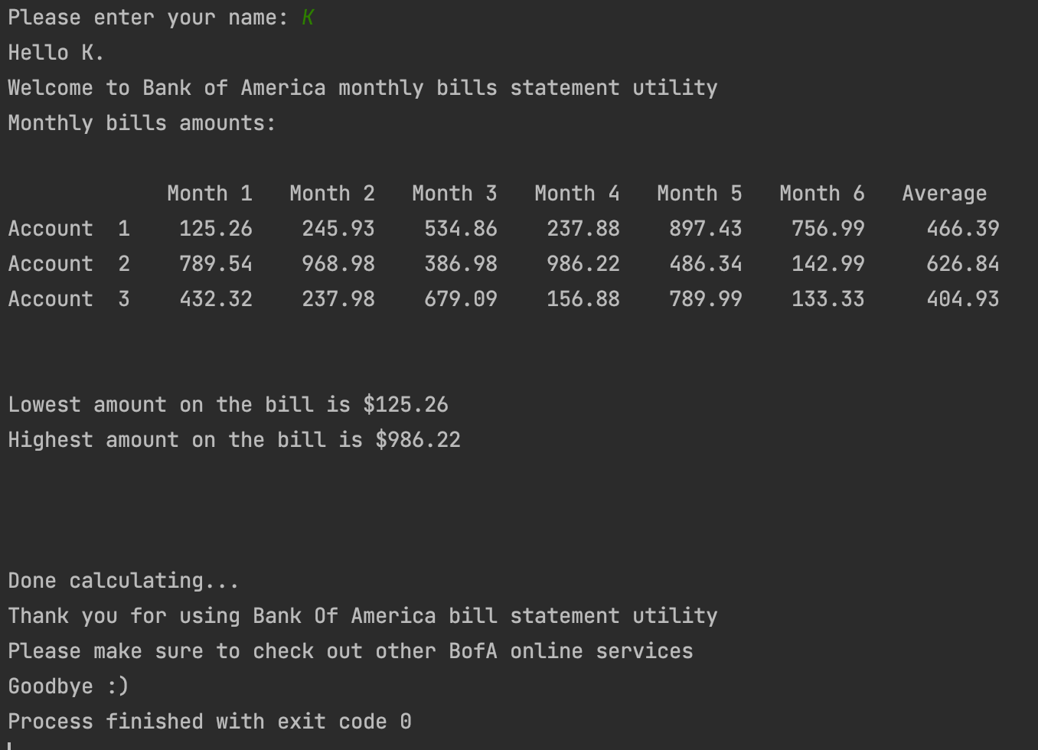

This assignment incorporates two-dimensional array mechanics which allows inputting and calculation of data from multiple accounts and multiple months. I wanted to play with the outputBarChart method a little bit and produce a chart, but then I figured out that I spent a lot of time hitting the wall and not going anywhere. Google search did not give me any sufficient solution either (maybe I haven't researched Stack Overflow enough) I will spend time learning about two-dimensional arrays and implement the solution later. This version of the program will not have the outputBarChart method active.